WA SALT GROUP
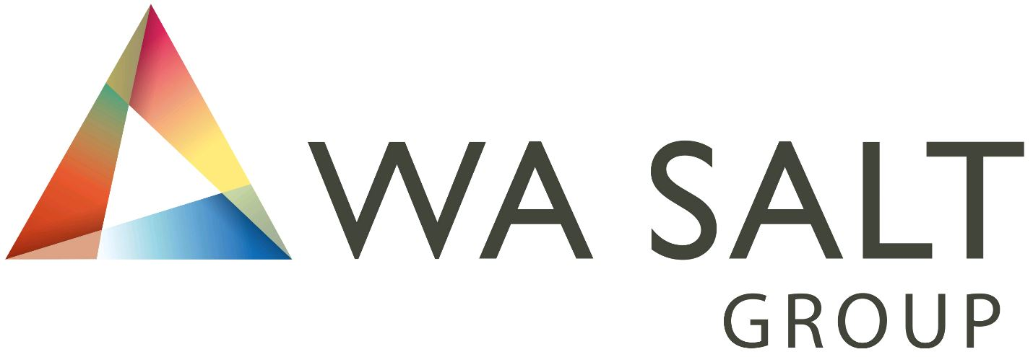
SAFETY DATA SHEET Group 1

1. IDENTIFICATION OF THE MATERIAL & COMPANY
Product: Graded salt: Aussie/Natural Lake Salt, Bubble Salt, Butchers Salt, Coarse Salt, Crude Salt, Low Sodium Salt, Fine/Flossy Salt, Flossy Salt, Iodised Flossy Salt, Iodised Fine Salt, Iodised Table Salt, Less Powder Salt, Scrub Salt, Superfine (Fine) Salt, Swimming Pool Salt, Premium Pool Salt, Pure Fine Salt, Petroleum Salt, Table Salt, Water Softener Salt and Dishwasher Salt.
Synonyms: Salt, Solar Salt, Rock Salt, Halite, Table Salt
Use: Used as food flavouring, food preservative, in fabric dye industry, to cure hides and skins, glazing pottery, chemical manufacture, soaps and metal recycling
Supplier: WA Salt Group, 187 Cockburn Road, North Coogee WA 6163
Telephone: +61 (8) 9431 9431
EMERGENCY TELEPHONE NUMBER +61 (8) 9431 9431

2. HAZARDS IDENTIFICATION
NOT CLASSED AS HAZARDOUS ACCORDING TO GHS CRITERIA
Risk Phrases: None allocated
Safety Phrases: None allocated

3. COMPOSITION OF THE MATERIAL
Chemical Name: Sodium chloride (NaCl)
CAS #: 7647-14-5
Concentration: > 95%

4. FIRST AID MEASURES
Inhalation: Remove to fresh air. Get medical attention for any breathing difficulty.
Ingestion: Give several glasses of water to drink to dilute. If large amounts were swallowed, get medical advice.
Skin Contact: Remove any contaminated clothing. Wash skin with soap and water for at least 15 minutes. Get medical attention if irritation develops or persists.
Eye Contact: Wash thoroughly with running water. Get medical advice if irritation develops.
High water intake facilitates urinary excretion and relief of temporary symptoms

5. FIRE FIGHTING MEASURES
HAZCHEM CODE: NONE ALLOCATED
This material is non combustible. Flames on or in the vicinity of this material can be extinguished using conventional fire fighting agents and procedures. However, when heated to decomposition, it emits toxic chloride and sodium oxide fumes.

6. ACCIDENTAL RELEASE MEASURES
Recover product where practical. Sweep up remnants and dispose of in a sealed container in licenced waste. Flush the area to dissolve in sufficient amounts of water to meet existing water quality standards.

7. HANDLING & STORAGE
Store under cover at relative humidities below 75% to retard caking. Cycling salt through the 75% relative humidity zone will rapidly increase the onset of caking. In transit, cover to prevent rain and physical damage.

8. EXPOSURE CONTROLS/ PERSONAL PROTECTION
Adequate ventilation is recommended. Under normal circumstances protective wear is not required, however under very dusty conditions a dust mask is recommended. Gloves, goggles etc. may be used for comfort.

9. PHYSICAL & CHEMICAL PROPERTIES
Appearance: Translucent to white crystals, granules or powder
Crystal Shape: Cubic/pyramidal in shape
Molecular weight: 58.448
Properties of NaCl: The composition by weight is 39.3% sodium & 60.7% chloride
Density: 1.2 gm/cc
Ph: is in the range of 7.0 to 7.8
Melting Point: 801 degrees C
Boiling Point: 1413 degrees C at 101.3 kPa
Vapour Pressure: 1mm Hg at 865 degrees C
Flashpoint: Not applicable
Flammability Limits: Not applicable
Solubility in Water: 35.7 gm/100 ml at 0 degrees C, 39.12 gm/100 ml at 100 degrees C

10. STABILITY & REACTIVITY
Chemical Stability: Stable
Conditions to Avoid: None
Incompatible materials: Bromium Triflouride, Lithium, strong acids
Hazardous Reactions: Reacts violently with Bromium Trifluoride and Lithium

11. TOXICOLOGICAL INFORMATION
Salt has not been classed as hazardous according to GHS criteria. Some health effects can be:
Ingestion: After excessive ingestion salt may cause oedema or elevated blood pressure and may cause vomiting. Salt is a stomach irritant
Eye Contact: Salt is an irritant and may abrade and cause an inflammation of the eye
Skin Contact: May be an irritant to some sensitive persons, or when applied to open cuts and abrasions
Inhaled: Irritant to mucous membranes

12. ECOLOGICAL INFORMATION
Ensure appropriate measures are taken to prevent excess material entering the
Environment.

13. DISPOSAL CONSIDERATIONS
Clean material can be re used. Dispose of waste material only in accordance with the applicable federal, state and local laws and regulations.

14. TRANSPORT INFORMATION
NOT CLASSIFIED AS A DANGEROUS GOOD BY THE CRITERIA OF THE ADG CODE
UN Number: None allocated
Hazchem Code: None allocated
Dangerous Goods Class: None allocated
Subsidiary Risk: None Allocated

15. REGULATORY INFORMATION - Not Applicable

16. OTHER INFORMATION
The data of this material safety data sheet are current at the time of issue and relate only to the materials and not to its use in combination with any other material or in any process. WA Salt Group disclaim responsibility for damages resulting from the use of or reliance upon the data of this material safety data sheet. No expressed or implied warranties are given other than those implied by Commonwealth, State or Territory legislation.

